PRESS RELEASE 15 OCTOBER 2018
SHADOW FIRE PROMOTIONS, INC. ™ “YOUR CHICAGO SOURCE FOR WRESTLING”™

FOR IMMEDIATE RELEASE

Shadow Fire Promotions, Inc. is proud to continue our association with the original GLOW (Gorgeous Ladies of Wrestling) girls, as we team with Hollywood, Lightning, and Royal Hawaiian to sponsor their first Original GLOW Girl Cruise on September 7th to 14th, 2019.

Avoid fall’s chill with a Mexican vacation as, once again, we take to the ocean to cruise with GLOW, travelling from Long Beach, CA to Cabo San Lucas, Mazatlán, & Puerto Vallarta, Mexico.

This time, we not only feature the Gorgeous LADIES, but we feature some very handsome men, as this cruise includes GLOW referee Steve Blance and host/announcer & producer during GLOW seasons three and four, Johnny C, in addition to cruise veteran Lightning and several heretofore “lost” GLOW girls, cruise newcomers British Bombshell Godiva, Illinois native Jungle Woman (hey, it’s a jungle in here!), Royal Hawaiian, Major Tanya, and more special guests in the works.

Our previous work with Hollywood includes being an authorised distributor of Hollywood’s shirts, hats, hoodies, and videos.

The image below is one of the Official posters for this event and contains a link to the website to register and obtain more information on this once-in-a-lifetime experience to meet not just the Gorgeous Ladies of Wrestling, but some of the other on-air personalities of GLOW. If unable to click the link, just head to http://www.originalglowgirls.com

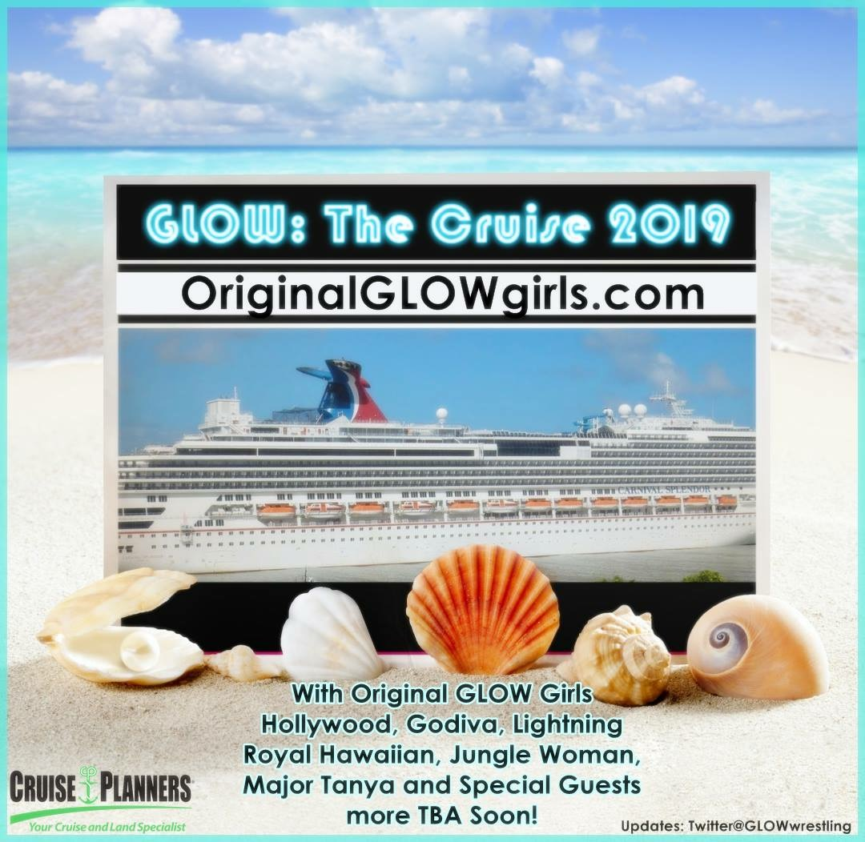
--
Shadow Fire Promotions, Inc.
"Your Chicago Source For Wrestling"™
Visit us on the web at http://www.sfpincchicago.com
Post to our message board at http://www.sfpincchicago.com/boards
Catalogue updates: http://groups.yahoo.com/group/SFPCatalog
Facebook: http://www.facebook.com/sfpincchicago
Yahoo Messenger: sfpincchicago2003
Skype (IM only): sfpincchicago@hotmail.com
P.O. Box 2746
Chicago, IL 60690
(847) 489-2087

