PRESS RELEASE 10 OCT 2016
SHADOW FIRE PROMOTIONS, INC. ™ “YOUR CHICAGO SOURCE FOR WRESTLING”™

FOR IMMEDIATE RELEASE

We are extremely proud to have renewed our partnership with The AfterGLOW Fan Party.

The AfterGLOW Fan Party is taking their show out to sea with Shadow Fire Promotions, Inc.! Following up on the success of the first AfterGLOW Fan Party At Sea, which took place last year in early summer, this time the cruise takes you out to the Caribbean in February, a perfect way to get away from winter!

On a related note, our renewed partnership with The AfterGLOW Fan Party has us not only distributing the Official DVDs of the first AfterGLOW Fan Party (autographed by Gorgeous Ladies of Wrestling (GLOW) girl Roxy Astor), but for the first time having our own Official Merchandise as an Official Sponsor of the AfterGLOW Fan Party At Sea.

This once-in-a-lifetime sea cruise will feature several GLOW girls, to include, for the very first time, the re-uniting of Ashley Cartier and Tina Ferrari, the latter of whom was formerly known as Ivory in WWE, and Shadow Fire Promotions, Inc. will once again be podcasting live from the cruise, with scheduled interviews to include Tina and Ashley, and possibly many others, as well.

Plus, what’s a party without music? The cruise will feature music from Gioia Bruno, of the dance group Exposè.

The cruise will also feature plenty of exclusive opportunities to hang with the GLOW girls, and there will even be an 1980s style prom.

The cruise will take place on February 12 through the 19th, so it’s a great time for the wrestling love of your life to spend Valentine’s Day in a very special way with you and will include a special Valentine’s Day dance while underway!

The cruise starts and ends in New Orleans, with scheduled stops in Cozumel, Mexico; Roatan, Honduras; Harvest Caye, Belize; and Costa Maya, Mexico.

Our Official Merchandise will be grey Shadow Fire Promotions, Inc. t-shirts (perfect for getting autographs of the GLOW girls as a momento of this great cruise!) with our name, slogan, website, and flame logo and we hope to have a stock image soon, as we are presently seeking bids to make shirts.

Sign up for the Cruise today at 80sAfterGLOW.com, and continue to pay attention to Shadow Fire Promotions, Inc. across all our social media, including Facebook.com/sfpincchicago; twitter.com/sfpincchicago; and sfpincchicago.com/boards and our website, sfpincchicago.com for more details!

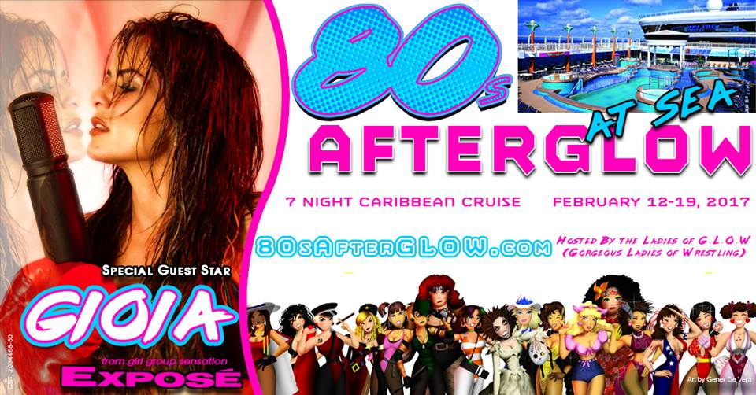

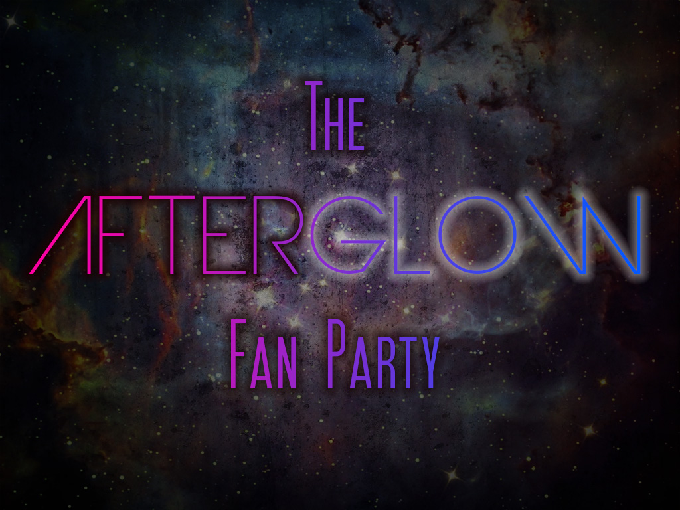
--
Shadow Fire Promotions, Inc.
"Your Chicago Source For Wrestling"™
Visit us on the web at http://www.sfpincchicago.com
Post to our message board at http://www.sfpincchicago.com/boards
Catalogue updates: http://groups.yahoo.com/group/SFPCatalog
Yahoo Messenger: sfpincchicago2003
GTalk: sfpincchicago
AOL IM: sfpincchicago
MSN Messenger: sfpincchicago@hotmail.com
P.O. Box 2746
Chicago, IL 60690
(847) 489-2087

