PRESS RELEASE 11 JUL 2016
SHADOW FIRE PROMOTIONS, INC. ™ “YOUR CHICAGO SOURCE FOR WRESTLING”™

FOR IMMEDIATE RELEASE

Following our distribution deal with Roxy Astor and the AfterGLOW Fan Party at the 50th Annual Cauliflower Alley Club Reunion in 2015 (the next instalment of the AfterGLOW Fan Party recently took place Carnival Cruise Lines; check out the podcast section on our site or facebook.com/afterglowfanparty for more information); we signed another Gorgeous Ladies of Wrestling (G.L.O.W.) wrestler at the 51st Cauliflower Alley Club Reunion.

Shadow Fire Promotions, Inc. is extremely proud and excited to announce that we have signed another distribution deal with a major wrestling superstar: Hollywood, formerly of the Gorgeous Ladies of Wrestling.

Hollywood burst onto the wrestling scene in 1986, as part of G.L.O.W., the Gorgeous Ladies of Wrestling, and wrestled all five “seasons” of the show (GLOW was not a traditional wrestling promotion; it was a television show that featured wrestling).

After GLOW was cancelled, Hollywood found herself bit by the wrestling bug. With a love for the sport of professional wrestling, Hollywood returned to wrestling bouncing around local California independent promotions for a while. Still wanting more, and knowing she could offer more to the business she loved, Hollywood approached the women wrestlers she knew and with whom she had previously worked, hired camera operators, and started her own company featuring women's wrestling, mixed wrestling, cat fighting and superheroine videos, and is involved in all aspects of it as a talent, editor, and producer.

Today, Hollywood runs her own company, called Hollywould Productions (with the deliberate misspelling) full time. She also performs stunts in movies and television, and you may have seen her in Pauly Shore’s Son-In-Law movie (she’s the mud wrestler, along with Lightning from GLOW, aka Cheryl Rusa), or Days of Our Lives (among others!).

Wrestling and convention promoters interested in booking Hollywood or any of the other original GLOW girls can email glowrestlers@gmail.com.

Shadow Fire Promotions will be featuring all of Hollywould Productions’ videos, as well as Hollywood’s GLOW (and other) photos ($15, plus shipping) and shirts ($25, plus shipping) immediately, and will have its own section of merchandise featured on sfpincchicago.com, as do all our clients. Hollywood can autograph her 8x10s and t-shirts upon request.

Hollywood will be modelling her own t-shirts and we hope to be able to get them and her 8x10s uploaded to Facebook (facebook.com/sfpincchicago) and Pinterest (pinterest.com/sfpincchicago) shortly.

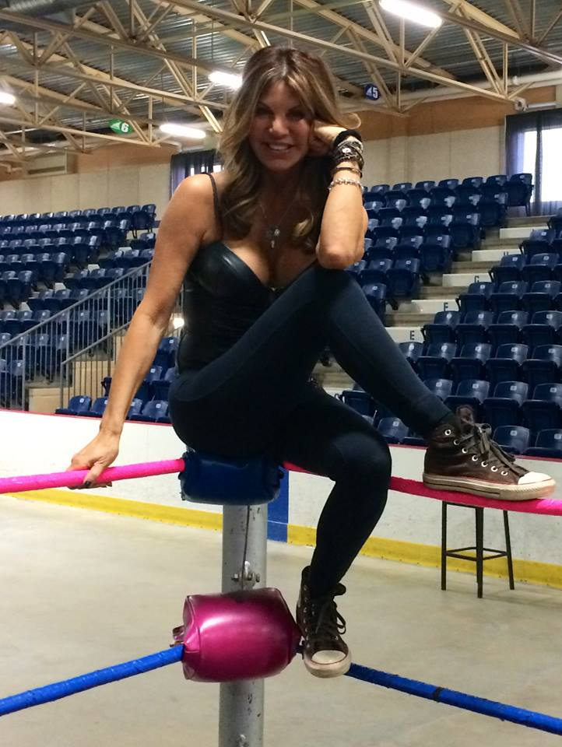

--
Shadow Fire Promotions, Inc.
"Your Chicago Source For Wrestling"™
Visit us on the web at http://www.sfpincchicago.com
Post to our message board at http://www.sfpincchicago.com/boards
Catalogue updates: http://groups.yahoo.com/group/SFPCatalog
Facebook: http://www.facebook.com/sfpincchicago
Google+: Shadow Fire Promotions, Inc.
Yahoo Messenger: sfpincchicago2003
AOL IM: sfpincchicago
Skype (IM only): sfpincchicago@hotmail.com
P.O. Box 2746
Chicago, IL 60690
(847) 489-2087

