PRESS RELEASE 12 MAY 2008
SHADOW FIRE PROMOTIONS, INC. ™ “YOUR CHICAGO SOURCE FOR WRESTLING”™

Shadow Fire Promotions is pleased to announce the alliance between Shadow Fire Promotions, Inc. and Girl With A Camera Media Services, Ltd.

Girl With A Camera Media Services, Ltd. (GWAC) was formed in 2004 by “HollDoll” Miss Hollie Thompson. Miss Thompson, a graduate of the University of Iowa with a Bachelor’s Degree in Cinema is a professional photographer and videographer, having worked across the U.S. in Cedar Rapids, IA; St. Louis, MO; Dallas, TX; Brooklyn, NY; Minneapolis, MN; Las Vegas, NV; Chicago, IL (our hometown); Washington, DC; Orlando, FL; Denver, CO; Los Angeles, CA; Detroit, MI; just to name a few places.

In addition to filming, Miss Thompson is also skilled in video and photo editing, finding that best image or the best parts of a movie, and editing it so it looks just right, and enjoys working with people to create and capture memories.

In addition to the usual bands, weddings, and models, Miss Thompson seeks to diversify her portfolio, shooting anything and everything. An example would be her first professional gig after the formation of GWAC where she was hired by a Catholic school to travel with them and be the professional videographer/photographer for their 8th grade class trip to Washington D.C. Still today, in 2008 she has just created another cycle of video memories for the class of 2012.
Miss Thompson admits she loves the experience of it all, loving the opportunity to meet and work with new people. Miss Thompson firmly believes that without people, she wouldn't be able to thrive, and that every person is beautiful in their own way.

Miss Thompson’s excellence in her work lies in her special skill in connecting with individuals in a short period of time, so that they trust her behind the camera.

Miss Thompson is available for photographing or videotaping professional wrestling or MMA events, (among other events), and can be reached via her MySpace: http://www.myspace.com/girlwithacameraltd; her in-progress website, http://www.gwacproductions.com; or via e-mail at gwac.media_services@yahoo.com

Miss Thompson considers herself a true fan of both sports, MMA and wrestling, finding that the action shots and entrance videos used in both genres are her stock-in-trade.

Shadow Fire Promotions, Inc. feels that this alliance between our two media companies, a media distributor in SFP and a media producer in GWAC is a natural partnership that brings SFP closer to the goal of being a full-service media company, and we are extremely proud to announce this partnership.

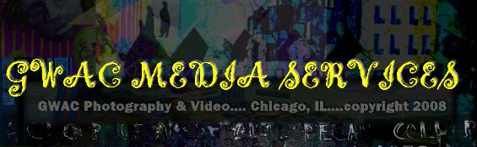
--
Shadow Fire Promotions, Inc.
"Your Chicago Source For Wrestling"
Visit us on the web at http://www.sfpincchicago.com
Post to our message board at http://p082.ezboard.com/bshadowfireinc27540
Catalogue updates: http://groups.yahoo.com/group/SFPCatalog
Yahoo Messenger: sfpincchicago2003
AOL IM: sfpincchicago
MSN Messenger: sfpincchicago@hotmail.com
P.O. Box 2746
Chicago, IL 60690
(847) 489-2087

